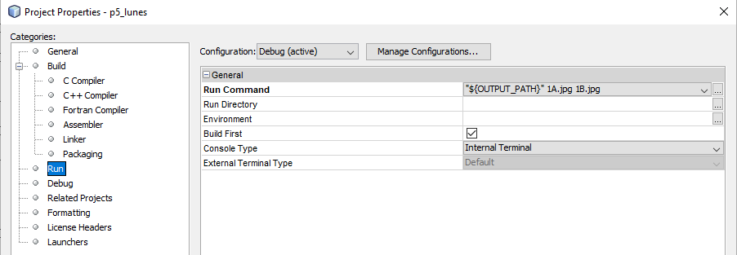

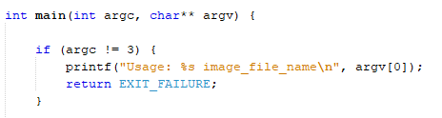

#include <stdio.h>

#include <stdlib.h>

#include <opencv/cv.h>

#include <opencv/highgui.h>

int main(int argc, char** argv) {

if (argc != 3) {

printf("Usage: %s image_file_name\n", argv[0]);

return EXIT_FAILURE;

}

//CV_LOAD_IMAGE_COLOR = 1 forces the resultant IplImage to be colour.

//CV_LOAD_IMAGE_GRAYSCALE = 0 forces a greyscale IplImage.

//CV_LOAD_IMAGE_UNCHANGED = -1

IplImage* Img1 = cvLoadImage(argv[1], CV_LOAD_IMAGE_COLOR);

IplImage* Img2 = cvLoadImage(argv[2], CV_LOAD_IMAGE_COLOR);

IplImage* ImgBlack = cvCreateImage(cvSize(Img1->width, Img1->height), Img1->depth, Img1->nChannels);

IplImage* ImgTrans = cvCreateImage(cvSize(Img1->width, Img1->height), Img1->depth, Img1->nChannels);

// Always check if the program can find a file

if (!Img1) {

printf("Error: fichero %s no leido\n", argv[1]);

return EXIT_FAILURE;

}

// a visualization window is created with title 'image'

cvNamedWindow("color", CV_WINDOW_NORMAL);

// img is shown in 'image' window

cvShowImage("color", ImgTrans);

cvWaitKey(0);

__m128i unos = _mm_set1_epi8(1);

for (int pixel = 0; pixel < 256; pixel++) {

for (int fila = 0; fila < Img1->height; fila++) {

//uchar *pImg1 = Img1->imageData + (fila * Img1->widthStep);

__m128i *pImg1 = (__m128i *) (Img1->imageData + fila * Img1->widthStep);

__m128i *pImg2 = (__m128i *) (Img2->imageData + fila * Img2->widthStep);

__m128i *pImgBlack = (__m128i *) (ImgBlack->imageData + fila * ImgBlack->widthStep);

__m128i *pImgTrans = (__m128i *) (ImgTrans->imageData + fila * ImgTrans->widthStep);

for (int columna = 0; columna < Img1->widthStep; columna = columna + 16) {

*pImg1 = _mm_subs_epu8(*pImg1, unos);

*pImgBlack = _mm_adds_epu8(*pImgBlack, unos);

*pImgBlack = _mm_min_epu8(*pImgBlack, *pImg2);

*pImgTrans = _mm_max_epu8(*pImg1, *pImgBlack);

pImg1++;

pImg2++;

pImgBlack++;

pImgTrans++;

}

}

cvShowImage("color", ImgTrans);

cvWaitKey(1);

}

cvWaitKey(0);

// memory release for img before exiting the application

cvReleaseImage(&Img1);

// Self-explanatory

cvDestroyWindow(argv[1]);

return EXIT_SUCCESS;

}